Project Design Phase-II Technology Stack (Architecture & Stack)

|  |  |
| --- | --- |
| Date | 03 October 2022 |
| Team ID | PNT2022TMID20641 |
| Project Name | Visualizing and Predicting Heart Disease Using Interactive Dashboard |
| Maximum Marks | 4 Marks |

Technical Architecture:

USER IBM CLOUD ADMIN

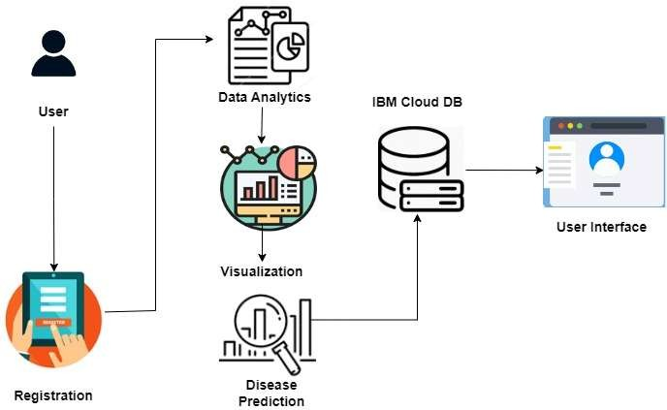

Table-1 : Components & Technologies:

|  |  |  |  |
| --- | --- | --- | --- |
| **S.No** | **Component** | **Description** | **Technology** |
| 1. | Importing data | You can transfer data from outside sources and integrate it with data you acquire using Analytics using Data Import. | Python, IBM Cognos. |
| 2. | Data Cleaning | Data cleaning is the process of organising and fixing erroneous, improperly structured, or otherwise disorganised data. | Python, IBM Cognos. |
| 3. | Data Preprocessing | Any type of processing done on raw data to get it ready for another data processing operation is referred to as data preprocessing, a part of data preparation. | Python, IBM Cognos. |
| 4. | Training data | The portion of the original data used to train the machine learning model is known as training data. | IBM Cognos. |
| 5. | Testing data | Test data is data which has been specifically identified for use in tests, typically of a computer program. | Python, IBM Cognos, IBM Cloud. |
| 6. | Machine learning model | A machine learning model is a file that has been trained to recognize certain types of patterns. You train a model over a set of data, providing it an algorithm that it can use to reason over and learn from those data | Python, IBM Cloud. |
| 7. | Improve model performance | Accuracy is one metric for evaluating classification models. Informally, accuracy is the fraction of predictions our model got right. | Python, IBM Cloud. |
| 8. | Checking accuracy | A data accuracy check, sometimes called a data sanity check, is a set of quality validations that takeplace before using data. | IBM Cognos or IBM Cloud, Python |

Table-2: Application Characteristics:

|  |  |  |  |
| --- | --- | --- | --- |
| **S.No** | **Characteristics** | **Description** | **Technology** |
| 1. | Security Implementations | The passwords need to be encrypted in order to ensure user privacy and security. | e.g. SHA-256, Encryptions, IAM Controls, OWASP etc. |
| 2. | Availability | The system will be available for 24*7 in a day to  allow easier access at any time. |  |
| 3. | Performance | The system will be fast and efficient in predicting the results. |  |